**Name:- Abhishek Uttam Chaudar**

**PART A**

**What will the following command do?**

1. **echo”Hello, World**
2. **name="Productive"**
3. **touch file.txt**
4. **ls -a**
5. **rm file.txt**
6. **cp file1.txt file2.txt**

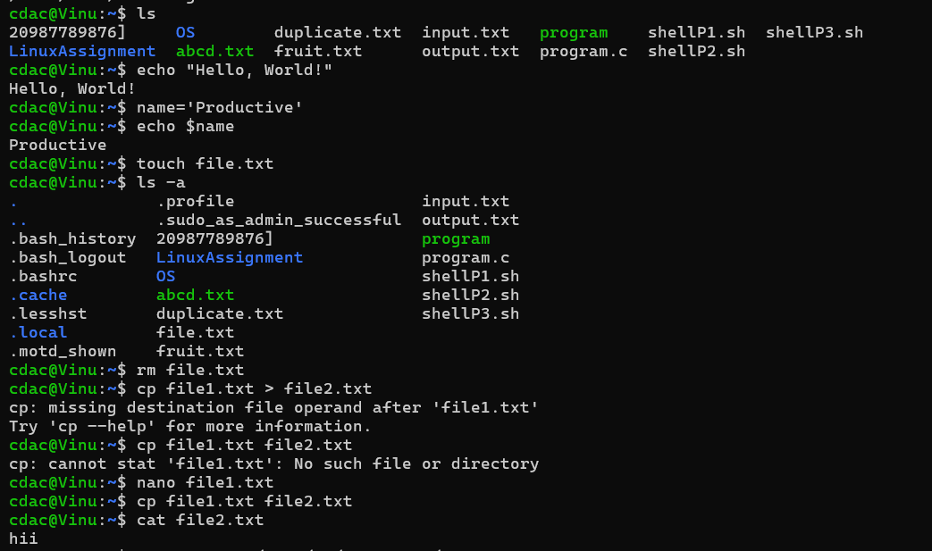

1. **chmod 755 script.sh**
2. **grep "pattern" file.txt**
3. **kill PID**
4. **mkdir mydir && cd mydir && touch file.txt && echo "Hello, World!" > file.txt && cat file.txt**
5. **ls -l | grep ".txt"**

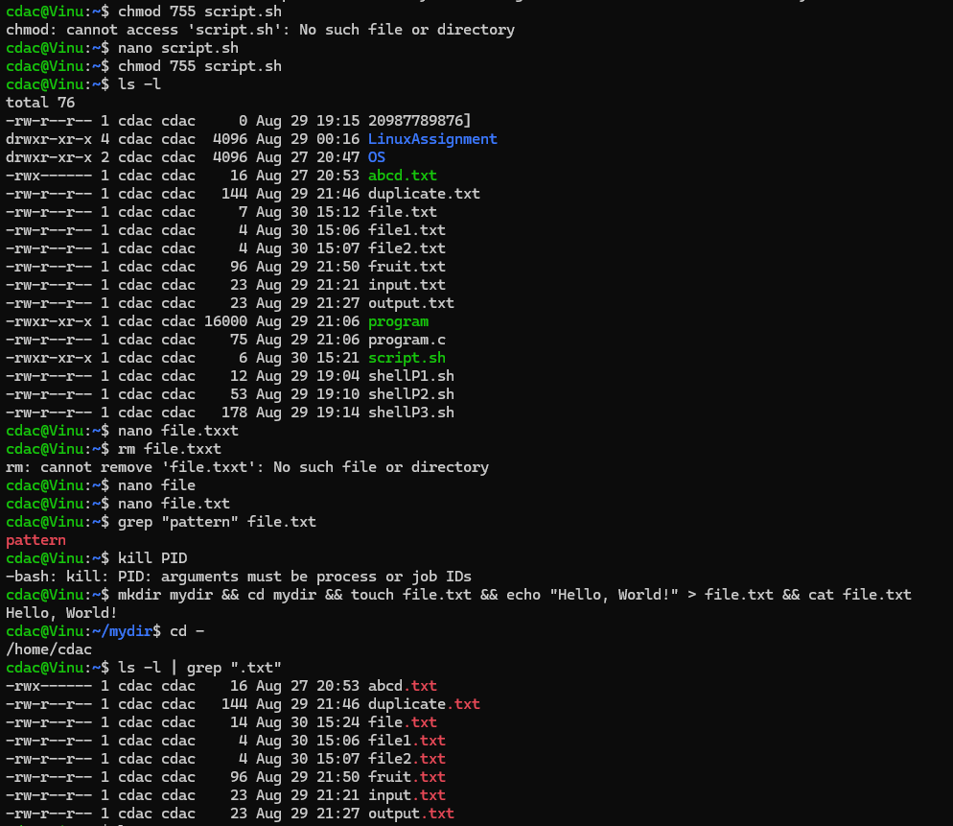

1. **cat file1.txt file2.txt | sort | uniq**
2. **ls -l | grep "^d"**
3. **grep -r "pattern" /path/to/directory/**
4. **cat file1.txt file2.txt | sort | uniq –d**
5. **chmod 644 file.txt**
6. **cp -r source_directory destination_directory** •
7. **find /path/to/search -name "*.txt"**
8. **chmod u+x file.txt**
9. **echo $PATH**

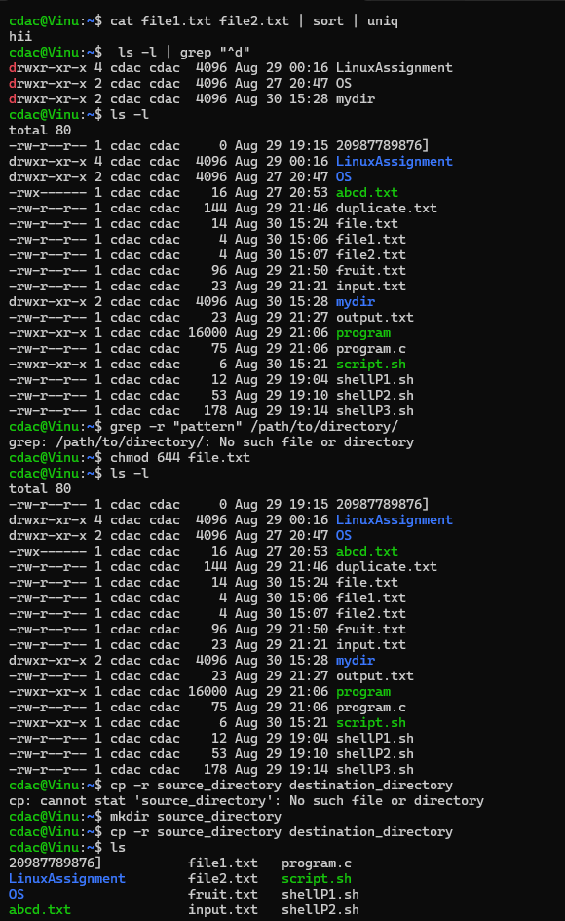

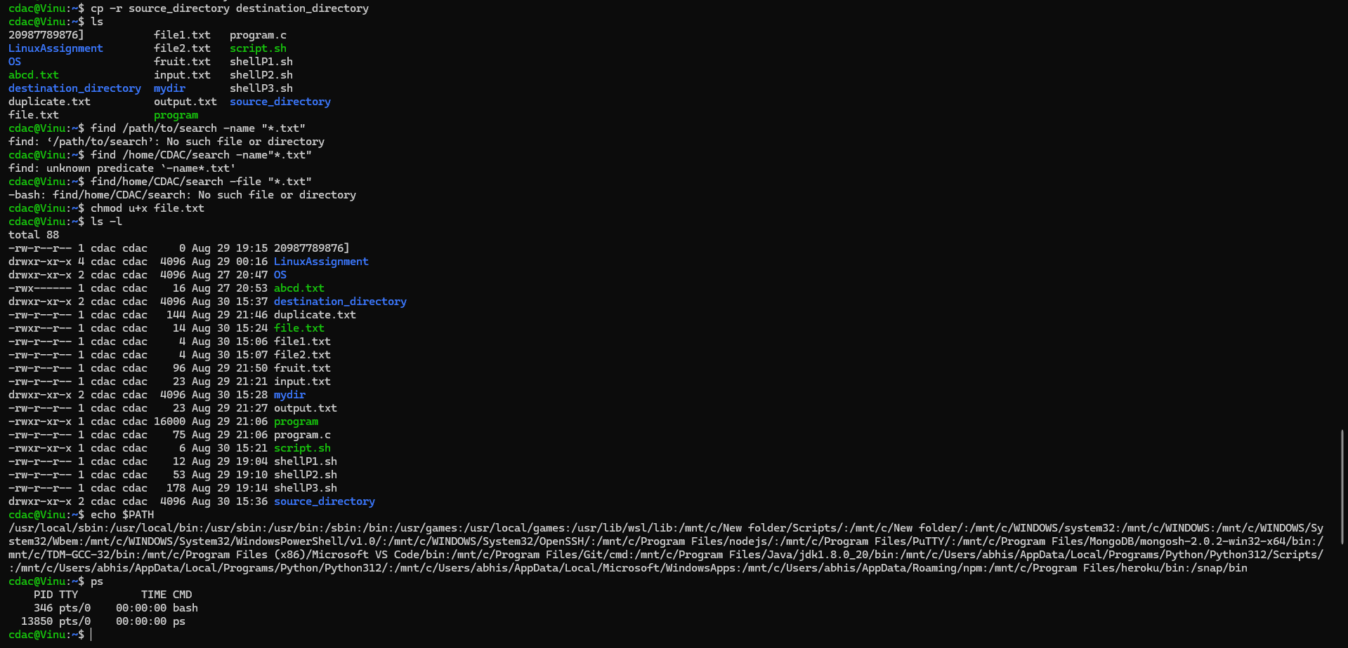

**PART B**

Identify True or False:1. Ls is used to list files and directories in the directory.

Ans. True

2. mv is used to move the files and directories.

Ans. True

3. cd is used to copy files and directories.

Ans. False

4. pwd stands for "print working directory" and displays the current directory.

Ans. True

5. grep is used to search for patterns in files.

Ans. True

6. chmod 755 file.txt gives read, write, and execute permissions to the owner, and read and execute permissions to group and others.

Ans. True

7. mkdir -p directory1/directory2 creates nested directories, creating directory2 inside directory1 if directory1 does not exist.

Ans. True

8. rm -rf file.txt deletes a file forcefully without confirmation.

Ans. True

**Identify the Incorrect Commands:**

1. **Chmodx is used to change file permissions. --- Incorrect**

**Correct – chmod**

1. **cpy is used to copy files and directories. --- Incorrect**

**Correct – cp**

1. **mkfile is used to create a new file. --- Incorrect**

**Correct – nano OR touch**

1. **catx is used to concanate files. --- Incorrect**

**Correct – cat**

1. **rn is used to rename the files. --- Incorrect**

**Correct – mv**

**PART C**

**1: Write a shell script that prints "Hello, World!" to the terminal.**

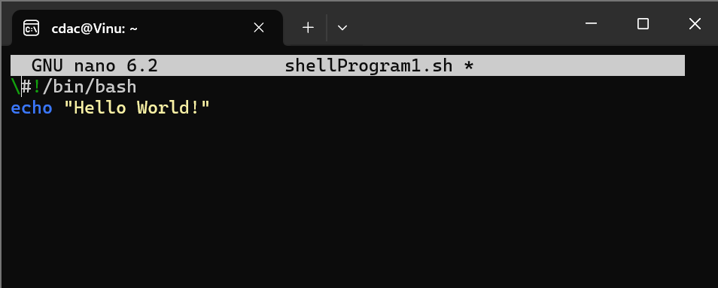

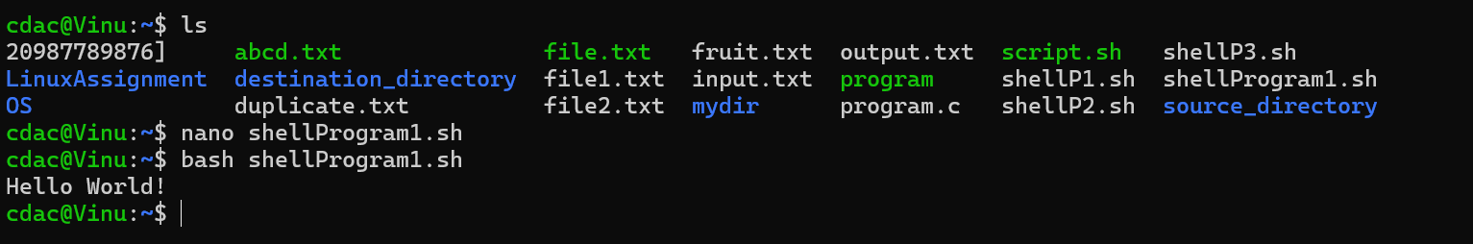

**2.** **: Declare a variable named "name" and assign the value "CDAC Mumbai" to it. Print the value of the variable.**

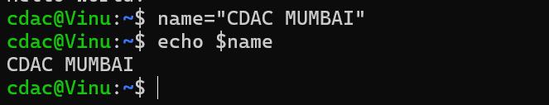

**3: Write a shell script that takes a number as input from the user and prints it.**

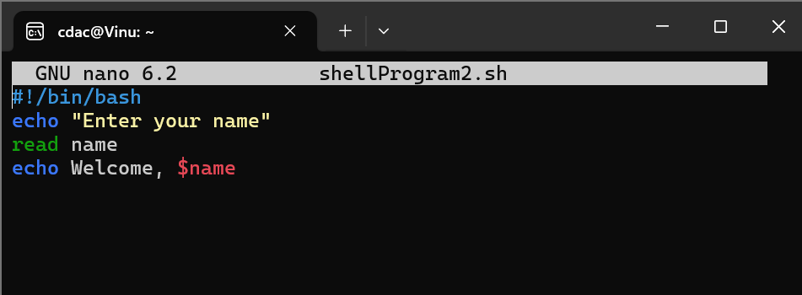

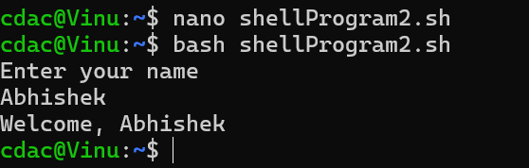

**4: Write a shell script that performs addition of two numbers (e.g., 5 and 3) and prints the result.**

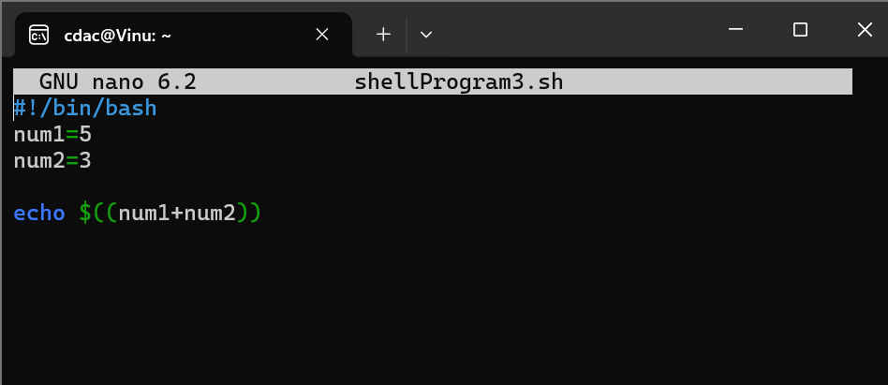

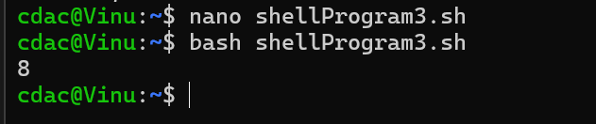

**5: Write a shell script that takes a number as input and prints "Even" if it is even, otherwise prints "Odd"**

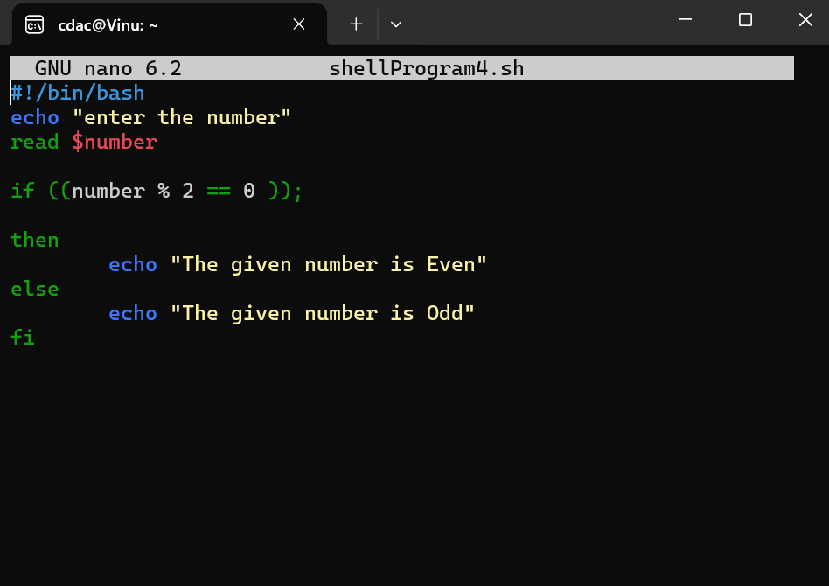

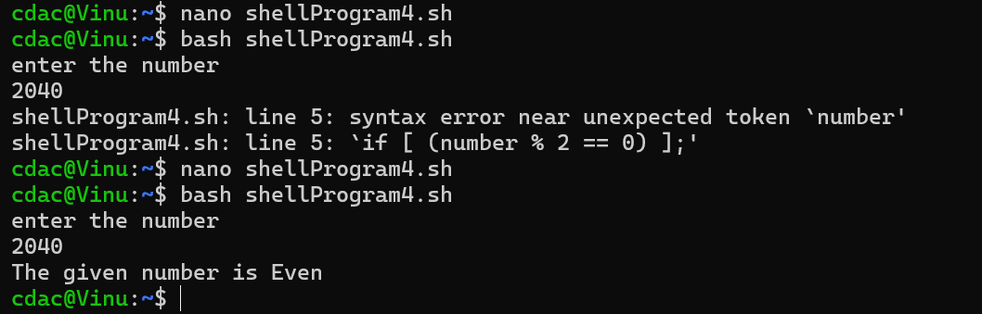

**6: Write a shell script that uses a for loop to print numbers from 1 to 5**

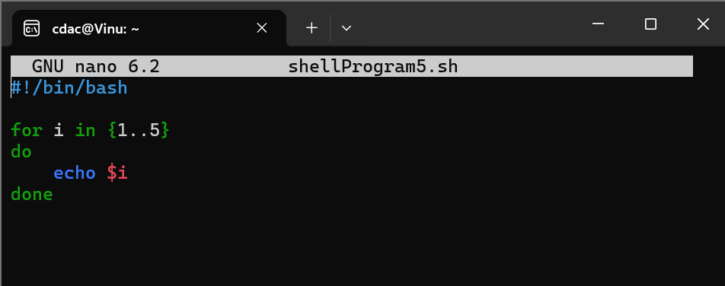

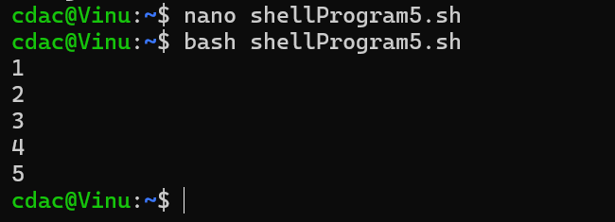

**7: Write a shell script that uses a while loop to print numbers from 1 to 5**

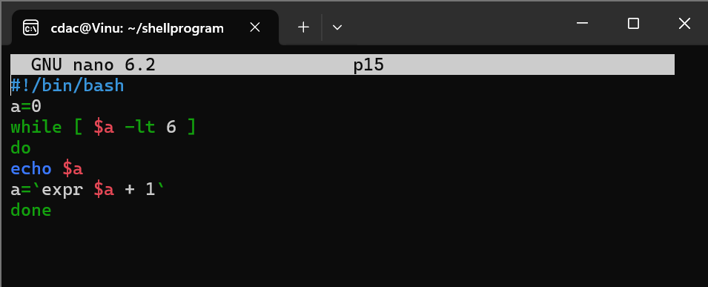

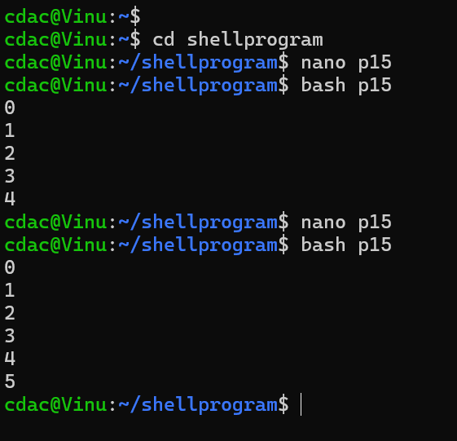

**8: Write a shell script that checks if a file named "file.txt" exists in the current directory. If it does, print "File exists", otherwise, print "File does not exist".**

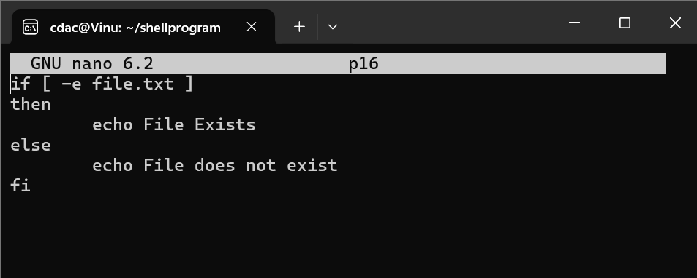

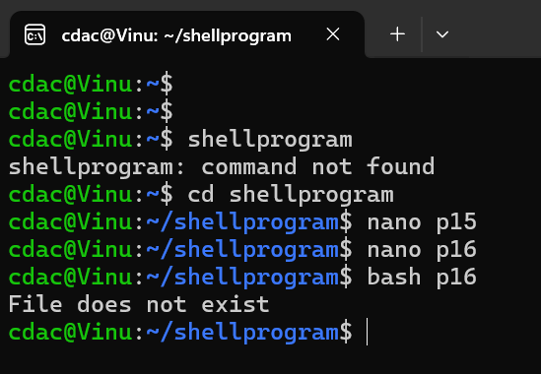

**9.** **Write a shell script that uses the if statement to check if a number is greater than 10 and prints a message accordingly.**

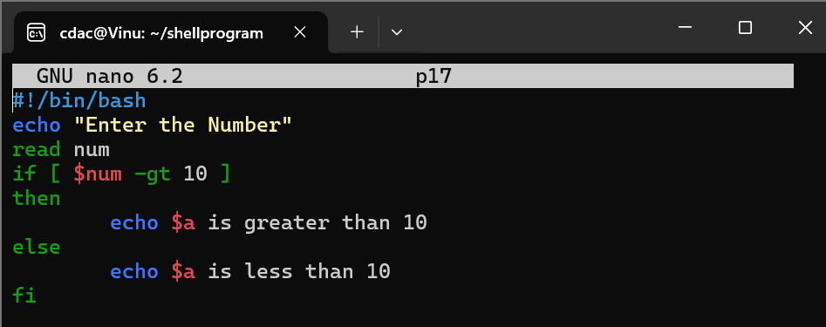

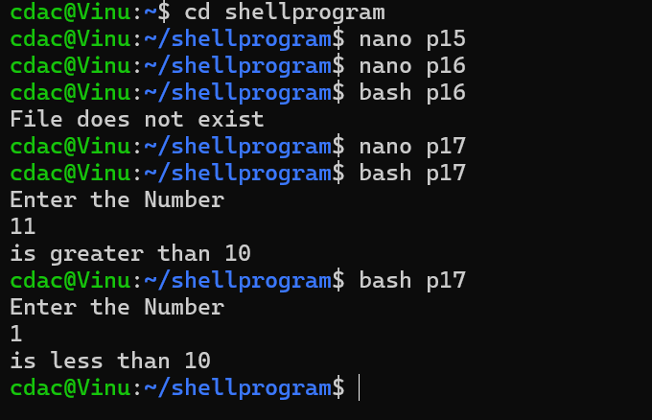

**10.** **Write a shell script that uses nested for loops to print a multiplication table for numbers from 1 to 5. The output should be formatted nicely, with each row representing a number and each column representing the multiplication result for that number.**

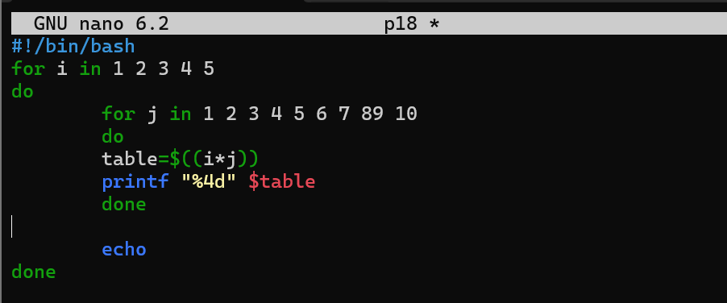

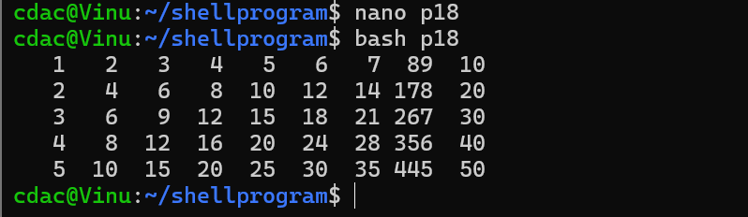

**Question 11: Write a shell script that uses a while loop to read numbers from the user until the user enters a negative number. For each positive number entered, print its square. Use the break statement to exit the loop when a negative number is entered.**

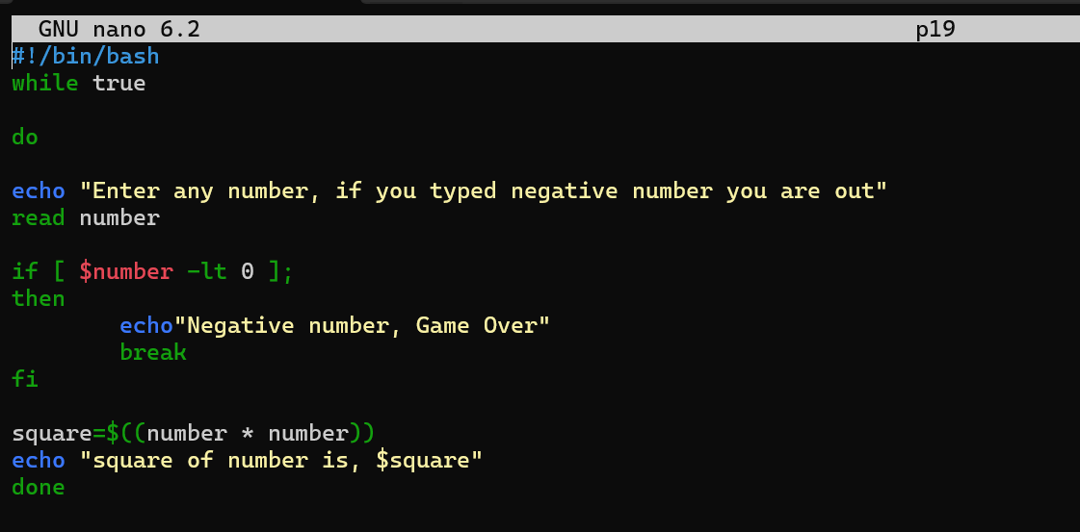

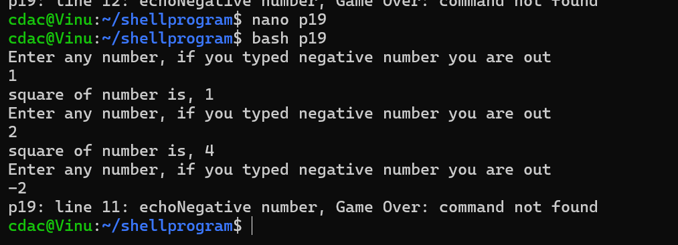

**PART E**

